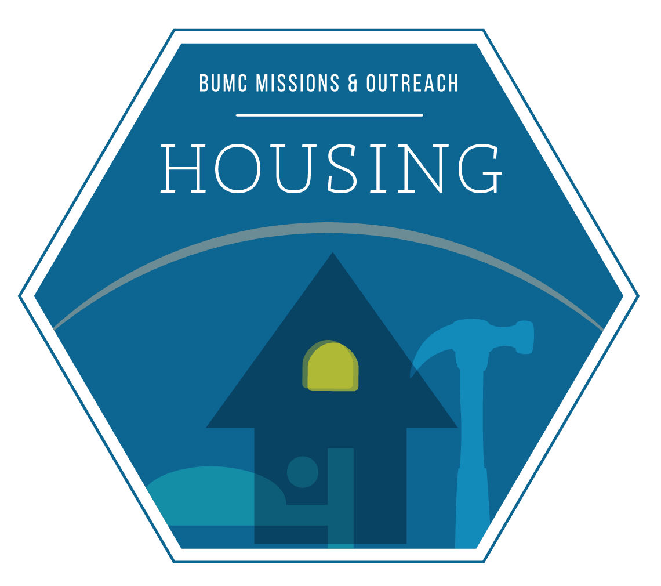
WOMEN BUILD/SPRING COMMUNITY 2016
101 Scruggs Ave. Franklin, TN 37064

DAY 1, April 2 – Saturday (30 volunteers)
Install wall panels & tie plates
Straighten & Brace walls
Install porch beams
Build and install fly rafters
Build storage shed
Install house wrap & Dow
Clean up site
DAY 4, April 16 – Saturday (30 volunteers)
Install siding & fascia
Install blocking for drywall, cabinets, shelving
Clean up site

DAY 7, May 7 – Saturday (30 volunteers) WOMEN ONLY
Paint siding & exterior trim 2nd coat
Install trim & baseboard
Install shoe molding on vinyl floors only
Set & fill nail holes & caulk
Paint interior doors & trim 2nd finish coat
Clean up site
DAY 9, May 21 – Saturday (30 volunteers)
Install landscaping
Remove poly hanging below siding at foundation
Install crawl space rim board insulation
Install mailbox & house numbers
Clean up site

FALL FAITH BUILD 2016 (Registration will begin in JUNE)
Overlook Subdivision (Columbia, TN) Address TBD

DAY 5, August 27 – Saturday (30 volunteers)
Complete installing siding & fascia
Caulk siding & prep for painting
Clean house interior
Paint interior walls two coats
Second stage poly
Clean up site
DAY 6, September 10 – Saturday (30 volunteers)
Paint siding & exterior trim 1st coat
Install interior doors, trim and baseboards
Install cabinets, vanities, & countertops
Paint interior doors & trim
Clean up site

DAY 7, September 17– Saturday (30 volunteers)
Paint siding & exterior trim 2nd coat
Install trim & baseboard
Install shoe molding on vinyl floors only
Set & fill nail holes & caulk
Paint interior doors & trim 2nd finish coat
Clean up site

DAY 8, September 24 – Saturday (28 volunteers) Prepare floors for carpet installation
Install front elevation detail, shutters, vents, etc.
Install closet shelving
Install bath accessories, cabinets & door knobs
Clean up site
Build Notes: Volunteers need to arrive by 7:45am to allow time for registration. The build day ends between 4 & 5 pm. Tools will be provided. If you want to bring your own hand tools & tool belt, you are welcome to do so; however, please make sure that they are clearly labeled so they don’t get lost in the shuffle of Habitat tools. Open-toe, open-heel shoes are not permitted at the build site. Tennis shoes or work boots are best. If it is raining, you might want to bring an extra pair of shoes for the ride home because the site can get muddy. We build rain or shine, so if it looks cloudy, please bring a poncho. Must be at least 16 to participate.

